SCHOOL DROPOUT AND THE JUNTOS PROGRAMME IN 2016

INTRODUCTION
The importance of social programmes is that they generate necessary conditions so that the least favored members of society can have improvements in their living standard and that these are sustainable over time. Thus, the purpose of the Juntos social programme in Perú is for its beneficiaries to achieve autonomy by promoting nutrition, health and education through incentives. The objective of this document is to evaluate whether the performance of Juntos, in terms of its objective of reducing the dropout rate, has had the desired results in 2016.

CONDITIONAL CASH TRANSFER PROGRAMMES
The “Programa Nacional de Apoyo Directo a los más Pobres” (National Program of Direct Support for the Poorest), Juntos, is one of the most important social programmes in Perú. The programme consists of providing monetary incentives to the poorest households on a conditional basis. Households that benefit must meet certain commitments, such as the use of health, nutrition and education services.
The program provides conditional assistance to the actions of the beneficiaries, and, therefore, the government only transfers resources to people who meet certain criteria. Conditional cash transfer programmes seek to end the cycle of poverty through the development of human capital.

THEORY OF CHANGE AND IMPACT EVALUATION
The theory of change explains how activities are understood to produce a series of results that contribute to achieving the expected final impacts. It can be developed for any level of intervention, be it an event, a project, a programme, a policy, a strategy or an organization.
Graph 1. Schematic representation of a theory of change
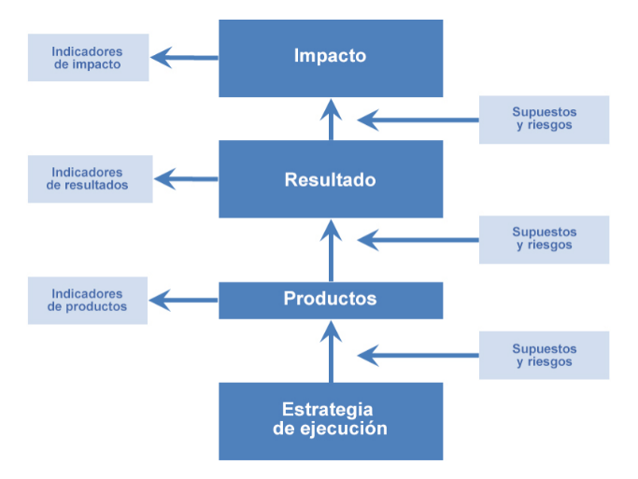Source: United Nations International Children's Emergency Fund, Supplementary Programme Note on the Theory of Change. Peer Review Panel session, 2014.
The theory of change can support an impact evaluation in various ways. It serves to identify:
- Specific evaluation questions, especially in relation to those elements of the theory of change for which there is still no substantial evidence.
- Intermediate results that can be used as indicators of success, in situations where the impacts of interest will not occur within the time frame of the evaluation.
- Contextual factors that may be relevant and should be addressed in data collection and analysis.
The impact evaluation can be useful to check the degree of success along the causal chain and, if necessary, examine these alternative causal pathways.

DROPOUT RATES IN PERÚ
Dropout is a situation in which a student withdraws from the educational system. It refers to a phenomenon that has to do with the fact that a large number of people withdraw from classrooms. In this scenario many factors come together, some considered conditioning factors of the phenomenon; and other structural, are considered determining factors.

Tables 1 and 2 show dropout rates from 2012 to 2016, and average years of education from 2015 to 2016, respectively. It seems that, on average, this rate has been declining over time and this could be explained by a number of factors. However, it is not of our interest discuss extensively those factors or estimate their impact. Instead, we ought to be more interested in estimating the impact directly attributable to the Juntos programme. The methodological section will address how to accomplish this objective.

Table 1. Dropout rate, basic education (% of ages 13-19 with incomplete basic education).
 | 2012 | 2013 | 2014 | 2015 | 2016
PERÚ | 13.9 | 13.5 | 13.2 | 12.1 | 11.9
Area
Urban | 10.5 | 11.1 | 11.0 | 10.4 | 9.8
Rural | 20.3 | 18.2 | 17.4 | 15.7 | 16.1
Poverty
Not poor | 10.6 | 10.5 | 11.0 | 9.9 | 9.6
Not extreme poor | 19.3 | 17.9 | 17.0 | 14.7 | 15.2
Extreme poor | 24.5 | 28.1 | 21.4 | 25.6 | 23.3
Region
Amazonas | 26.9 | 22.3 | 19.0 | 16.2 | 19.7
Ancash | 10.9 | 8.4 | 6.4 | 6.0 | 9.8
Apurímac | 7.0 | 6.1 | 7.0 | 7.1 | 5.7
Arequipa | 4.5 | 4.5 | 6.4 | 3.9 | 4.8
Ayacucho | 11.3 | 9.7 | 10.9 | 9.0 | 5.4
Cajamarca | 21.4 | 21.2 | 18.2 | 14.5 | 19.6
Callao | 8.5 | 13.9 | 6.0 | 13.6 | 9.4
Cusco | 8.6 | 4.8 | 4.5 | 4.4 | 6.5
Huancavelica | 8.3 | 6.0 | 7.0 | 4.9 | 7.1
Huánuco | 17.7 | 14.3 | 17.7 | 15.9 | 16.0
Ica | 13.0 | 8.8 | 11.3 | 10.3 | 7.9
Junín | 11.2 | 7.9 | 14.1 | 11.6 | 12.5
La Libertad | 19.1 | 20.7 | 20.4 | 15.7 | 17.0
Lambayeque | 21.9 | 22.5 | 15.3 | 15.4 | 14.0
Lima Metropolitana | 7.7 | 8.2 | 10.2 | 10.1 | 8.4
Lima Provincias | 12.1 | 13.1 | 9.5 | 9.9 | 11.3
Loreto | 30.3 | 25.8 | 26.2 | 22.9 | 20.6
Madre de Dios | 10.3 | 10.1 | 8.3 | 11.8 | 10.6
Moquegua | 3.1 | 3.9 | 5.1 | 2.4 | 7.0
Pasco | 18.1 | 14.5 | 11.7 | 11.2 | 11.0
Piura | 21.5 | 24.3 | 21.7 | 18.5 | 14.0
Puno | 5.6 | 5.9 | 6.4 | 7.2 | 7.5
San Martín | 26.9 | 26.0 | 19.6 | 19.0 | 21.9
Tacna | 6.3 | 2.7 | 6.8 | 6.0 | 5.0
Tumbes | 17.0 | 17.0 | 11.4 | 12.8 | 9.1
Ucayali | 29.9 | 27.3 | 27.7 | 25.8 | 18.8
Source: “Estadística de la Calidad Educativa–ESCALE” (Educational Quality Statistics), Ministry of Education of Perú. Own elaboration.

Table 2. Average years of education by region in 2015 and 2016.
Region | 2015 | 2016 | Var. %
Amazonas | 8.0 | 8.1 | 1.3
Ancash | 8.9 | 9.1 | 2.3
Apurímac | 7.9 | 7.9 | -0.1
Arequipa | 10.6 | 10.5 | -1.0
Ayacucho | 7.9 | 8.0 | 0.7
Cajamarca | 7.5 | 7.8 | 4.3
Callao | 11.0 | 11.3 | 2.5
Cusco | 8.7 | 8.8 | 1.3
Huancavelica | 7.5 | 7.7 | 2.7
Huánuco | 8.0 | 8.0 | 0.4
Ica | 10.7 | 11.0 | 2.3
Junín | 9.2 | 9.2 | 0.1
La Libertad | 8.7 | 9.1 | 4.0
Lambayeque | 9.5 | 9.6 | 1.1
Lima | 11.2 | 11.2 | 0.3
Loreto | 8.0 | 8.0 | 0.5
Madre de Dios | 9.1 | 9.1 | 0.1
Moquegua | 10.4 | 10.9 | 5.1
Pasco | 9.3 | 9.3 | -0.3
Piura | 8.8 | 8.8 | 1.0
Puno | 9.1 | 9.0 | -0.5
San Martín | 8.6 | 8.7 | 1.3
Tacna | 10.7 | 10.9 | 1.8
Tumbes | 9.7 | 9.8 | 0.8
Ucayali | 8.6 | 8.9 | 2.8
Source: “Encuesta Nacional de Hogares 2016 – ENAHO” (National Household Survey 2016), INEI. Own elaboration.

EVALUATION METHODOLOGY
Impact evaluation methodologies seek to compare the results of an intervention with those that would have occurred if the same intervention had not been implemented.
Since it is impossible to know these last results, what the impact evaluation techniques deal with is finding a counterfactual, that is, recreating the situation without intervention. To achieve this, two groups are taken into account in the evaluation: a treatment group and a control group, where both must have very similar characteristics and, in the optimum, only differ in that the members of the treatment group are affected by the intervention; while those in the control group, are not. If there were large differences between these two groups, we would reach the wrong conclusions.
For this work, the design of a random experiment will be taken. If we represent the basic problem of the evaluation: comparing the results in variable $Y$ between the treatment and control group, we have:
$$Y_{i}=αX_{i}+βT_{i}+ε_{i}$$
Where $T$ takes the value of 1 if the observation $i$ is part of the treatment group, and 0 if it is part of the control group.
Also, let $Y_{i}(1)$ be the value of $Y_{i}$ under treatment ($T_{i}=1$), and $Y_{i}(0)$ be the value of $Y_{i}$ for those who are not affected by the intervention ($T_{i}=0$), then the average effect of the intervention ($D$) can be represented as follows:
$$D=E\left(Y_{i}\left(1\right) | T_{i}=1\right)-E\left(Y_{i}\left(0\right) | T_{i}=0\right)$$
However, since the groups may not have been similar before the intervention, we can conclude that the difference between outcomes is not entirely due to the intervention. Then, we have:
$$D=ATE+B$$
Where:
- $ATE$: Average Treatment Effect
- $B$: Selection Bias
The Average Treatment Effect is a measure used to compare results in randomized experiments or quantify the impacts of relevant variables during evaluations of policies. On the other hand, the Selection Bias is the bias introduced by the selection of individuals, groups, or data for analysis such that an adequate randomization is not achieved.
If we find ourselves in a situation of a random experiment, the observations would not be conditioned, therefore, the term of Selection Bias would not be a problem anymore, guaranteeing that the difference between the outcomes of the treatment and control group represents the Average Treatment Effect of the intervention. Graph 2 represents an ideal experiment, which is when observations in both groups only differ in the treatment condition, giving us the most accurate estimation of an intervention’s impact.
Graph 2. The ideal experiment with an equivalent control group.
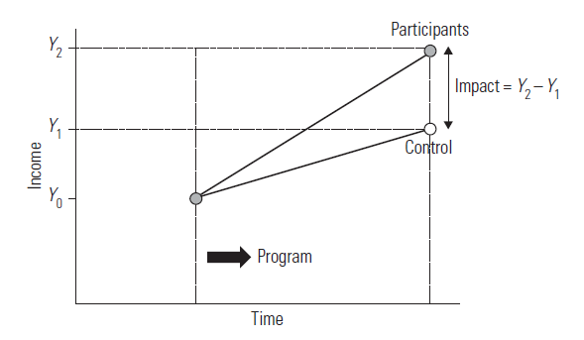
Source: Handbook on Impact Evaluation (World Bank), p. 34.
During an intervention’s impact evaluation, it is important to notice that getting observations from the treatment group is relatively an easy task since we can easily recognize them. The main issue while determining both groups comes due to the control group, as we need to find one that ideally fits observations in the treatment group.

JUNTOS: IMPACT ON SCHOOL DROPOUT 2016
Based on the previously mentioned methodology (randomized experiment), the following relationship is proposed:
$${Desertor}_{i}=α+β.{Juntos}_{i}+ε_{i}$$
Where:
- $Desertor$: takes the value of 1 if the observation dropped out and 0 otherwise.
- $Juntos$: takes the value of 1 if the observation is a beneficiary of the program and 0 otherwise.
In this relation, the estimated value of parameter $β$ ($\hat{β}$) represents the difference in outcomes between the treatment and control group.
For the mean difference problem, we must generate treatment and control groups, and, under the assumptions assumed, these must be random and have the same number of elements. Likewise, for this first evaluation, only people in situations of extreme poverty will be taken into account. Given these conditions, we obtain below a significance level of 5% the following results.

Table 3. Difference of means test for treatment and control groups (members in extreme poverty).
Source: Own elaboration with ENAHO’s data.

The results show that there is sufficient evidence not to reject the null hypothesis, which indicates that the difference between outcomes is zero; our $p-value$ accounts for this. We can conclude that the dropout rate for both treatment and control groups is the same. Thus, we conclude that one of the objectives of the social programme is not met.
On the other hand, we must remember that, for the previous evaluation, only people in extreme poverty were considered. The following table shows results for groups with members in poverty, that is, not necessarily in extreme poverty.
Table 4. Difference of means test for treatment and control groups (members in poverty).
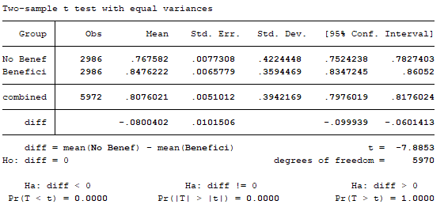
Source: Own elaboration with ENAHO’s data.

The previous table indicates that, if we are less strict regarding the formation of treatment and control groups for evaluation, and we take into account the participation of people above the extreme poverty line, the Juntos social programme achieves its objective in terms of reducing the dropout rate. As we can see, the null hypothesis of the mean difference test is rejected, and we have evidence that there is a significant difference between the dropout rates of the treatment group and the control group.

CONCLUSIONS
This document aims to provide an idea of the performance of the National Programme of Direct Support to the Poorest (Juntos) about its objective of promoting the use of educational services, which is finally reflected in the dropout rates among the beneficiaries. The randomized experiment method was used to carry out the exercise of impact evaluation of the social programme and filters were made in the treatment and control groups, initially conforming the groups only by people in extreme poverty, and later taking people who are above the extreme poverty line.
Under the proposed methodology, the results indicate that the impact of the programme on the dropout rate for the group of beneficiaries in extreme poverty is not significant. This may be due to the precarious and harsh living conditions these people have, so they prioritize the use of their resources to satisfy the most basic needs, such as food or health. Furthermore, we need to consider the extreme poverty line, which in 2015 was S/.169.00 per month, and the fact that the Juntos programme assistance is S/.200.00 every 2 months to get a clearer idea of the living conditions of its beneficiaries in extreme poverty and their priorities.
On the other hand, if an analysis is carried out considering only those beneficiaries who are above the extreme poverty line, we conclude that the program manages to meet the intended objective. This may be due to the fact that, among the members of this group, conditions exist to make education a priority, unlike the group of poorest people.
Finally, given the methodology used, estimates of the impact of the social programme on the dropout rate cannot be given accurately and daring to do so would be a great mistake. This is because the randomized experiment method is not a good one for an appropriate impact evaluation of the Juntos programme. Although we randomize the treatment and control groups, there may still be selection bias, which causes one of the assumptions of the randomized experiment method not to be fulfilled, and we can only limit ourselves to providing a general overview of compliance with the said objective. Thus, the designs for a correct impact evaluation of this social programme are quasi-experimental designs.

REFERENCES
Patricia Rogers – UNICEF (2014). Theory of change: methodological briefs – impact evaluation No. 2.
Peer Review Group meeting – UNICEF (2014). Supplementary Programme Note on the Theory of Change.
Shahidur R. Khandker, Hussain A. Samad, Gayatri B. Koolwal – World Bank (2009). Handbook on Impact Evaluation.
Lavado, P; Gallegos, J. – Centro de Investigación de la Universidad del Pacífico (2005). La dinámica de la deserción escolar en el Perú: un enfoque usando modelos de duración.
INEI (2016). Evolución de la pobreza monetaria 2009-2015.
Jiménez-Asenjo, Wendy & Gaete-Astica, Marcelo (2013). Education Exclusion and Dropping out in Public Schools of Costa Rica. Revista Electrónica Educare. Vol. 17(1), 105-128. Recovered from https://afly.co/y9s2.

Patricia Rogers (2014).
Jiménez-Asenjo & Gaete-Astica (2013).

